**Nowcasting Macroeconomic Indicators using Google Trends**

**Submitted By:**

**June 21, 2022**

**Master of Data Science**

**University of British Columbia, Okanagan Campus**

**Submitted By**

Aishwarya Sharma

Harpreet Kaur

Jagdeep Brar

**Project Partners**

Nick Newstead

Marina Smailes

(Statistics Canada)

**Instructors**

Irene Vrbik

Firas Moosvi

Image Sources: [UBC Logo](https://www.abdn.ac.uk/study/undergraduate/canada-university-of-british-columbia-4250.php), [Statistics Canada Logo](https://crippledscholar.com/2020/05/30/statistics-canada-isnt-collecting-information-on-disability-during-the-pandemic/), [Google Trends](•%09https:/techcrunch.com/2014/04/18/google-trends-debuts-email-notifications-for-search-topics-hot-searches-and-more)

**Table of Contents**

**Executive Summary** 1

**1.** **Introduction** 1

**2.** **Literature Review** 2

**3.** **Description of Dataset** 3

**3.1.** **GDP Data** 4

**3.2.** **Retail Trade Sales Data** 4

**3.3.** **E-Commerce Sales Data** 5

**3.4.** **Google Trends Data** 6

**4.** **Methodology** 7

**4.1.** **Data Extraction and Cleaning** 8

**4.2.** **Data Wrangling and Transformation of Time Series** 8

**4.3.** **Tools and Technologies** 10

***Why these models ?*** 11

***Model Selection to nowcast GDP growth rate*** 11

***Model Selection to nowcast Retail Trade Sales and E-Commerce Sales growth rate*** 13

**4.4.** **Rolling Prediction** 14

***One-step ahead prediction*** 14

***Prediction for two or more steps*** 14

**4.5.** **Prediction Error** 15

**4.6.** **Tuning Parameter** 15

***Parameter tuning for DFM + ARIMA*** 15

***Parameter tuning for Random Forest*** 15

**4.7.** **Block Bootstrap Resampling** 16

**5.** **Analysis and Interpretation of Results** 17

**5.1.** **Results Obtained for GDP** 17

**5.2.** **Results Obtained for Retail Trade Sales** 18

**5.3.** **Results Obtained for E-Commerce Sales** 20

**6.** **Impact of Google Trends** 21

**7.** **Challenges** 22

**8.** **Conclusions and Future Directions** 23

**References** 24

**Annexure A. Important Links** 25

# **Executive Summary**

The information on economic indicators is crucial for policymaking and taking decision at right time but this information is usually available with a lag. The nowcasting of economic indicators can help Statistics Canada to fill these lags and provide more timely information for policymaking. The economic indicators are the representatives of economic activity of country which may be captured by Google Trends. Thus, the goal of this project is to develop a methodology to predict macroeconomic indicators such as Gross Domestic Product (GDP), Retail Trade Sales and Retail E-Commerce Sales in real time by using the real time data source, Google Trends. Google Trends provide daily, weekly, and monthly reports on the volume of Google queries related to different industries/keywords which can exhibit the business cycles and provide signals about multiple aspects of the economy that can further be used to estimate the macroeconomic factors in real time. To nowcast these macroeconomic indicators, both econometric and machine learning models are used, and a comparative analysis is performed. The best suited model is chosen for each indicator and the predictions have been made to fill up the lagged information. All the obtained results are displayed on an interactive dashboard for easy access and understanding of results.

**Dashboard**: <https://nowcasting-indicators-canada.herokuapp.com/>

***Note:*** *The GDP values in the entire report require multiplication by 1,000,000 to get the actual amount in Canadian dollars. The Retail Trade Sales and E-Commerce Sales require multiplication by 1,000 to get the actual amount in Canadian dollars.*

# **Introduction**

The macroeconomic indicators influence the market movements of a nation and play a significant role in many analyses. Unfortunately, these indicators exhibit a lag, for instance, the GDP of first quarter is released in second quarter as the evaluation process takes time. This lag causes a delay in crucial information which could have been used for policy making or to make important decisions about investments. On the other hand, Google Trends capture interest of people on daily basis using their behavioral searches which can explain the economic activity of a nation at present as this information is available without any delay. Therefore, the economic activity exhibited by Google Trends can be used to estimate the trend of macro-economic indicators, for instance, the GDP for second quarter may have connection with Google searches in second quarter and these Google searches can be used to predict GDP for second quarter. That also explains why it is “nowcasting” not forecasting as Google Trends of specific month can be used to predict the macro-economic indicators for only that month not for the next month.

Nowcasting is basically predicting the present. This project aims to develop a methodology to predict macroeconomic indicators such as GDP, Retail Trade Sales and retail E-Commerce Sales with real-time data source Google Trends for Statistics Canada. The volume of queries for different keywords and categories extracted from Google Trends API serve as predictors for nowcasting the desired macroeconomic indicators. The key goals of the project are discussed below:

1. **Nowcasting quarterly GDP**: Our first goal is to nowcast the macroeconomic indicator GDP quarterly by using the real time Google Trends as predictors.
2. **Nowcasting monthly Retail Trade Sales**: The retail sales data are available monthly, so our objective is to nowcast the monthly Retail Trade Sales at national level**.**
3. **Nowcasting retail E-Commerce Sales**: The E-Commerce Sales data are also available monthly, so our objective is to nowcast the monthly retail E-Commerce Sales at national level.

To fulfil these objectives, two types of models have been used: (i) Econometric Models which include Dynamic Factor Model (DFM) and Autoregressive Integrated Moving Average (ARIMA) (ii) Machine learning models which include Least Absolute Shrinkage and Selection Operator (LASSO), Random Forest and XGBoost in combination with Principal Component Analysis (PCA). Thereafter, the model with least prediction error has been selected for each of the three considered indicators and used to nowcast the GDP, Retail Trade Sales and E-Commerce Sales and their growth rate as well. The obtained growth rate, value and 95% prediction interval for all three indicators are presented in visual and tabular form on dashboard in a user interactive format.

# **Literature Review**

Macroeconomic factors are the key drivers of economy, and their timely information helps in policy making. However, this information is available with a lag, for instance, the data for the present month’s GDP is generally published in the coming month/quarter which causes delay in decision-making. To overcome this issue of delayed information gave rise to nowcasting approach. This approach has recently gained the interest of economists and researchers as this approach provides the information on macroeconomic indicators in real-time. The macroeconomic indicators have some lag, and to fill this gap of information, Google Trends have widely been used as it may help in predicting the present [1]. The volume of queries on different industries may be correlated with the current level of economic activities in respective influential industry sector which may help to predict the subsequent data release [1].

Many researchers have used Google Trends for nowcasting the economic activity. Google Trends provide information about the business cycles and economic activities in economy. The salient features of these business cycles can be captured with few unknown factors using Dynamic Factor Models (DFMs) [2]. These models are applicable to high-dimensional time series data and are used to reduce the dimensionality. DFM became the mainstream tool for nowcasting GDP growth over the time. Over the time, new techniques emerged, and researchers have started to use machine learning algorithms for nowcasting macroeconomic factors. Woloszko [3] proposed a weekly tracker to estimate GDP for 46 Organisation for Economic Co-operation and Development (OECD) countries and G20 countries (excluding European Union). This OECD tracker is based on machine learning algorithms that estimate the relationship between Google Trends and GDP growth.

Dauphin et al. [4] have also used Google Trends data to estimate GDP growth, they provide comparative analysis of different nowcasting approaches such as Auto-Regressive (AR) models, DFM and some machine learning algorithms like Regularized Regression models, Random Forest, Support Vector Machine (SVM) and Neural Networks, and state that there is no one-size fits all model as different models are suitable for different datasets. Richardson et al. [5] used machine learning algorithms to nowcast GDP growth in New Zealand and their results show that machine learning algorithms like boosted trees, SVM and neural networks outperformed the traditional AR models for their study. The aforementioned studies indicate that traditional econometrics models and machine learning models both can be used for nowcasting macroeconomic factors, but the success and accuracy of the model may vary for different datasets. Therefore, a comparative study of traditional econometric models and modern machine learning algorithms may be more appropriate to fit a model on data in hand.

# **Description of Dataset**

As this project aims to nowcast the GDP, Retail Trade Sales and E-Commerce Sales for

Canada, we use data collected from Statistics Canada for these three indicators. The datasets are publicly available, and a brief description of data is provided below.

## **GDP Data**

The GDP data is extracted from Statistics Canada’s website which is comma separated file containing the information about quarterly GDP. The attribute “**Gross domestic product at market prices**” represents the GDP at national level and is used for our analysis. The time series of GDP value over the years is presented in Figure 1.

Data source: [**Gross domestic product (GDP), expenditure-based, Canada, quarterly**](https://www150.statcan.gc.ca/t1/tbl1/en/tv.action?pid=3610010401)

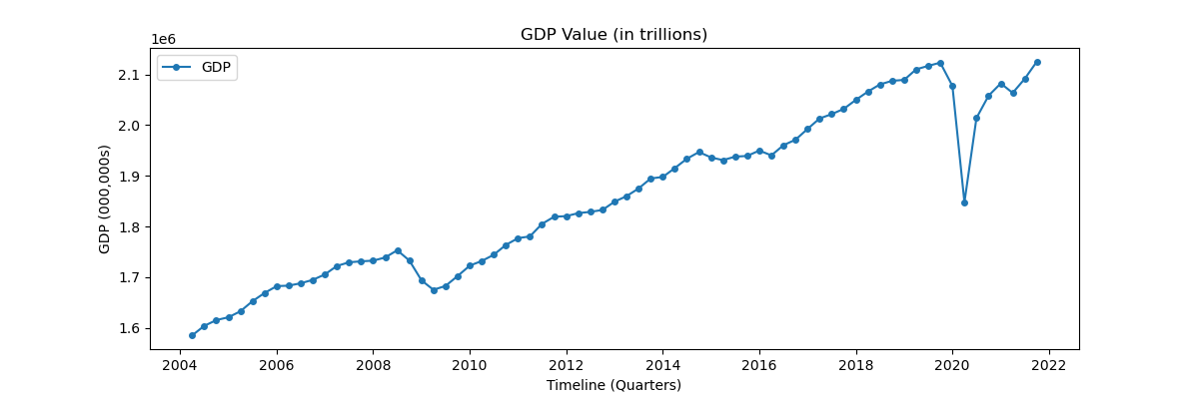

Figure 1: GDP Value over the years

## **Retail Trade Sales Data**

The Retail Trade Sales data has been obtained from Statistics Canada’s website as a comma separated file containing the information about the Retail Trade Sales as per the industry. The attribute “**Retail trade [44-45]**” represents the national level Retail Trade Sales and is used for our analysis. The Retail Trade Sales over the years are depicted in Figure 2.

Figure 2: Retail Trade Sales over the years

Data Source: [**Retail trade sales by industry**](https://www150.statcan.gc.ca/t1/tbl1/en/tv.action?pid=2010000802)

## **E-Commerce Sales Data**

This data is also obtained from Statistics Canada’s website as a comma separated file containing the information about the retail E-Commerce Sales. The attribute “**Retail E-commerce sales, seasonally adjusted**” represents the national level E-Commerce Sales and is used for our study.The E-Commerce Sales over the years are depicted in Figure 3.

Data Source: [**Retail E-commerce sales**](https://www150.statcan.gc.ca/t1/tbl1/en/tv.action?pid=2010007201)

Figure 3: E-Commerce Sales over the years

Snapshot 1: The demonstration of Google Trends for category “Events & Listings”

## **Google Trends Data**

Along with Statistics Canada’s data, Google Trends of different categories and queries have been used as predictors in our analysis, for example, some of the keywords are “Economic crisis”, “loans”, “GPS”, “unemployment”, “affordable housing”, “economy news”, “agriculture”, “forestry” and many more [Annexure A]. The snapshot 1 exhibits how the Google Trends look like for a specific category “Events & Listings”. We use python library “**Pytrends**” which provides access to Google Trends API to extract trends for desired categories and/or queries. The trends for few categories are shown in Figure 4.

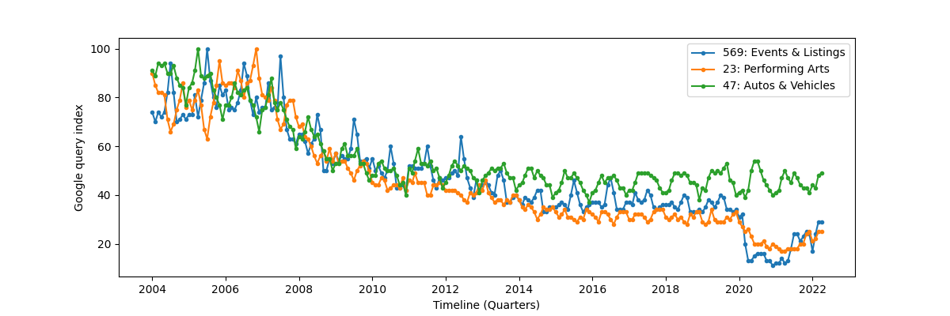

Figure 4: Google Trends for three categories

The y-axis represents Google query index which is calculated as below:

The Google Query Index represents the volume of queries at some time which is then rescaled to take minimum value 0 and maximum 100. It can be observed from Figure 4 that Google Trends time series starts from 2004 as the Google Trends are available from 2004 onwards. On the other hand, GDP data is available from 1961, Retail Trades Sales available from 1991 and E-Commerce Sales are available from 2016, so to maintain the consistency of data we opted the timelines, mentioned in Table 1, for our analysis.

Table 1: Timeline of data selected for analysis

|  |  |  |
| --- | --- | --- |
| **Economic Indicator** | **Timeline** | **Frequency** |
| Retail Trade Sales | 2004-2022 | Monthly |
| E-Commerce Sales | 2016-2022 | Monthly |
| GDP | 2004-2021 | Quarterly |

For GDP, we chose 141 categories and top 2 related queries of each category for further analysis and for Retail Trade Sales we consider 36 categories and top five related queries of each category, and 31 keywords have been selected for E-Commerce Sales analysis which comes under “E-Commerce Services” category. The list of categories and keywords considered is provided in Annexure A and the brief description of data is provided in Table 2.

Table 2: Dimension of the data selected |for analysis

|  |  |  |
| --- | --- | --- |
| **Indicator** | **Number of observations** | **Number of predictors (trends)** |
| Retail Trade Sales | 217 | 396 |
| E-Commerce Sales | 74 | 31 |
| GDP | 72 | 446 |

Data Source: [**Google Trends API**](https://trends.google.com/trends/?geo=CA)

We have appropriate amount of data for GDP and Retail Tarde Sales to perform analysis but the data for E-Commerce is not that much as the timeline starts from 2016. Thus, we implement different methods in order to find the suitable one for all the three indicators. The adopted methods are discussed in the following section.

# **Methodology**

In this section, we describe the workflow opted to nowcast the considered macroeconomic indicators and the workflow is visually presented in Figure 5. The detailed description of the methodology of the project along with the tools and techniques used is mentioned below.

Figure 5: Workflow of the project

## **Data Extraction and Cleaning**

All the data files required some cleaning and wrangling. The data were filtered for GDP value, Retail Trade Sales, and E-Commerce Sales at national level. Google trends data were extracted using the python library ‘Pytrends’. The data , extracted from Goggle Trends, are in monthly frequency and are stored in CSV files. The link to scripts to access the Google Trends data are provided in Annexure A.

## **Data Wrangling and Transformation of Time Series**

The GDP, Retail Trade Sales and E-Commerce Sales time series are transformed into growth rate time series. The obtained growth rate time series are stationary which can be used for further analysis. The growth rate is calculated as below:

where represents the value of any indicators for month/quarter . The obtained growth rate time series serve as response variable. The predictors/trends extracted from Google Trends require the following transformations in order to be stationary:

1. **Normalization**: The time series of different categories and keywords (of monthly frequency) have been normalized to have mean zero and standard deviation one.
2. **Detrending**: After normalization, the trends have been removed by using first order difference for GDP’s predictors/trends and E-Commerce Sales predictors, and second order differencing for the predictors of Retail Trade Sales.
3. **De-seasonality**: The predictors exhibit seasonal patterns which we have removed by subtracting the average Google Query Index of each month from respective month, for instance, the average value of all the January months in dataset has been subtracted from each January month.

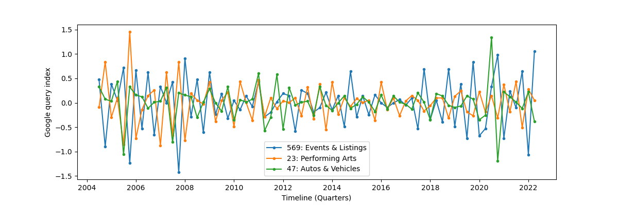

Figure 6: Stationary time series for three categories

These steps provide us with the stationary time series, and we check the stationarity of time series by using Augmented Dickey Fuller  (ADF) and Kwiatkowski-Phillips-Schmidt-Shin (KPSS) tests. The Figure 6 demonstrates the transformed time series of three categories presented in Figure 4.

The GDP predictors are fetched from Google Trends have monthly frequency like the other predictors, but the GDP data have quarterly frequency, so the GDP predictors require one more step of wrangling in order to match the frequency of response variable i.e., GDP growth rate.

**Transform GDP predictors data from monthly to quarterly:** The GDP value is available quarterly, so we have one observation for three months. On the other hand, we have three Google query indices for respective three months and three query indices are used as three predictors for that one quarter, demonstration of this transformation is provided in Tables 3 and 4 below for easy understanding.

After analysis, we found that only the “Predictor 3” (highlighted in Table 4) of each category is helpful in making predictions, so we dropped the first and second month’s Google Query Indices of the predictors selected for GDP and only the third month’s Google Trends have been used for further analysis.

Table 3. Presentation of monthly predictor for quarterly indicator

|  |  |
| --- | --- |
| Response Variable | Google Query Index for category “x” |
| GDP growth rate quarter 1 | January’s Google query index |
| February’s Google query index |
| March’s Google query index |

Table 4. Transformation of monthly predictor to quarterly predictor

|  |  |  |  |
| --- | --- | --- | --- |
| Response Variable | Google Query Index for predictor category “x” | | |
| Predictor 1 of category “x” | Predictor 2 of category “x” | Predictor 3 of category “x” |
| GDP growth rate quarter 1 | January’s Google query index | February’s Google query index | March’s Google query index |

## **Tools and Technologies**

Our data are time series data and require the nowcasting of macroeconomic indicators using the real time Google Trends data which are also time series data. As discussed in Section 2, econometric models have widely been used for nowcasting of macroeconomic indicators, but machine learning models have been outperforming the econometric models for some studies. Thus, we aim to use both the econometric models and machine learning models to estimate the relationship between predictors and macroeconomic factors. The considered models in both categories are depicted in Figure 7.

Figure 7: Outline of models used for analysis

### ***Why these models ?***

As described in Table 2, the dataset has more predictors than observations for two macroeconomic indicators and for the third indicator E-Commerce Sales the timeline starts from 2016 (not much data). Therefore, we choose models that can work well with more predictors and less samples. The econometric model ARIMA has been an established model for time series data, but it can not be used directly when dataset has more predictors than samples. So, to reduce the dimension of data first DFM model is applied and then ARIMA is implemented on the factors returned by DFM. The machine learning model LASSO can handle any number of predictors due to the existence of regularization function in objective function and it can remove less informative predictors by making their coefficients zero. This feature of LASSO makes it suitable model to try for our analysis. Next, we consider Random Forest as it can also be used when dataset has more predictors than samples as only a subset of predictors is applied on each split of decision trees, along with that it can capture the non-linearity or interaction of predictors well which makes it suitable to consider. Lastly, we consider XGBoost as it is well suited model to make predictions and provides the regularization feature as well. However, it can not be applied directly to dataset with more predictors and fewer observations, so we use PCA first to reduce the dimension of data and then XGBoost is implemented on the obtained components.

We have provided a comparative study of all the selected models in the coming section and based on their accuracy of predictions we have selected the best suitable model for the three macroeconomic indicators. Here, we provide the description of models that outperformed for our considered indicators and are used for making predictions.

### ***Model Selection to nowcast GDP growth rate***

After making comparison of all the chosen models, we found that the econometric models performs well than other models for GDP growth rate. The model is implemented by using the following steps:

1. **Prepare predictors data frame**: Prepare one data frame from all the selected categories and queries/keywords trends. We have 141 categories and 282 related queries (top two queries for each category) and 23 manually selected keywords, so in total we have 446 predictors for GDP indicator. After our analysis, we realised most of the queries/keywords are just adding noise to data and making the predictions worse and by using only categories data we get better results. Therefore, we move forward by choosing 141 categories data to make predictions for GDP growth rate. Then we checked the correlation of the time series of 141 categories with the GDP time series and selected categories which has positive or negative correlation 0.6 or more. As a result, we are left with 92 categories to consider for model fitting and making predictions. We made comparison of results by using all the 446 predictors, then only 141 categories, and then 92 correlated categories and found that later two outperform the former one (all 446 predictors). Moreover, we get almost same results by using 141 categories and 92 correlated categories. So, we chose 92 categories as we need to apply DFM on the predictors and selecting less predictors makes it more efficient.
2. **Apply DFM**: After choosing the appropriate predictors i.e., trends of 92 categories, DFM is implemented on the 92 predictors and 20 factors are calculated which capture the variation of 92 predictors and reduce the dimension of the predictor space. Then we need to choose appropriate number of factors out of 20 obtained factors as the 20 factors capture almost all the information and we do not require that much information as some of predictors may have nothing to do with GDP growth rate so want to throw some information away. So, the ‘number of factors’ is a parameter that needs to be tuned and after tuning we get 13 factors (parameter tuning is described in the coming section) to explain the appropriate information and should be used for further model fitting. While calculating the factors, the order of factors is chosen to be one so that the resultant residuals have no correlation, and the 20 resultant factors will remain time series as well.
3. **Testing and training set split**: We use 80% of data as training set and latest 20% of data as testing set.
4. **ARIMA model**: After getting the training set, ARIMA model is implemented on the training set and the parameters for lags are selected after observing the lag plots presented in Figure 8. The autocorrelation and partial autocorrelation plots show spike at order one which suggest the moving average (MA) and autoregression (AR) parameters of order 1. The “Integrated” order is chosen zero as the seasonality of data has already been removed.

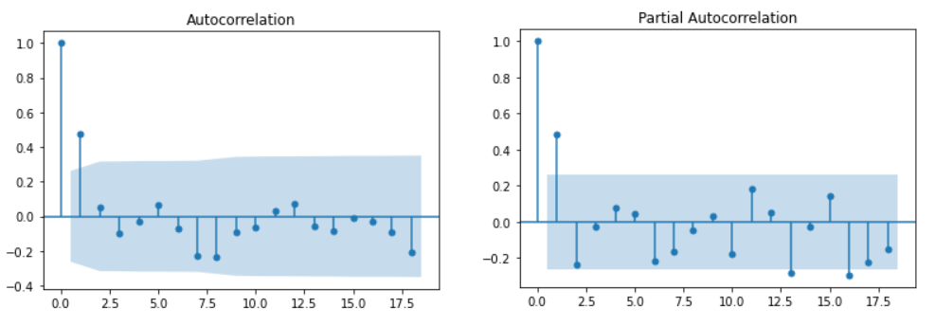

Figure 8: Autocorrelation and Partial Autocorrelation plots

Thus, we implement ARIMA model with parameters AR = MA = 1 and seasonality parameter zero on the 13 factors. The parameter tuning and predictions of this model are discussed in the coming sections.

### ***Model Selection to nowcast Retail Trade Sales and E-Commerce Sales growth rate***

Likewise, we implemented all the considered models to predict Retail Trade Sales growth rate and E-Commerce Sales growth rate. On the basis of prediction accuracy, we observe Random Forest outperformed other models for both indicators and so the steps to implement Random Forest are described as follows:

1. **Prepare predictors data frame**: Following the similar path, we prepare one data frame of all the considered categories and related top five queries and got predictors dataset consisting of 396 predictors for Retail Trade Sales. Similarly, we prepare a data frame of all 31-time series for E-Commerce Sales to use further for model fitting.
2. **Testing and training set split**: As we have more observations (217 observations) for Retail Trade Sales data set, so we can keep a few more data for test set. We use 70% of data as training set and latest 20% of data as testing set for Retail Trade Sales growth rate prediction. On the other side, the data for E-Commerce Sales starts from 2016 which means we do not have many observations for this indicator, so we keep 80% of data in our training set and use 20% latest data as testing set.
3. **Apply random forest**: It is well known that machine learning models cannot be applied to time series data directly as they can not capture the correlation between consecutive terms. So, to use machine learning models for time series, we need to add the lagged series of response variable to the predictors in order to capture the timely pattern. For, Retail Trade Sales and E-Commerce sales we added lagged series (of lag one) of the response variable ‘growth rate’ to the predictors as the autocorrelation plots suggest. Random Forest model can work with the dataset with more predictors than observations as it tries a subset of predictors for each split in decision trees. So, we do not need to reduce the dimension of data and model can be directly applied to all the predictors. Whereas we need to decide the ‘number of trees’ to choose for model which is our tuning parameter. The parameter tuning is performed in the coming section, and we select 100 number of trees as it provides a model with minimum prediction error for Retail Trade Sales growth rate. On the other hand, we select 600 number of trees for E-Commerce Sales growth rate model as it produces best results with least prediction error.

## **Rolling Prediction**

In this section, we made prediction in two ways. First is if prediction is required for next month or quarter (next does not mean future here it means next from the published month or quarter) only and other is if prediction is required for next two months or quarters. These two ways are described below:

### ***One-step ahead prediction***

For our analysis, one step ahead rolling prediction makes sense as we just require the information for the next step. Over the time, values of the considered macroeconomic indicators will be released and can be used to make further prediction. Therefore, we follow one step ahead rolling prediction technique where first we use the training set data to train the respective model and then a prediction is made for the next one step (month for Retail Trades Sales and E-Commerce Sales, and quarter for GDP) using the predictors of next step (Google Trends are available for next step). Once the prediction is made, the real data of that next step is appended to the training set and model (with same parameters) is fitted again on the appended train set and prediction is made for next step and so on.

### ***Prediction for two or more steps***

Sometimes, there is more lag in macroeconomic indicators than just one step, for instance, the present month is June, and the Retail Trade Sales and E-Commerce Sales are published till March, then we do not have any information for April and May sales for these two indicators. So, here two steps are missing, and we need to predict two steps. First step can be predicted as mentioned in above paragraph and for second step, predicted value of first step is appended to the training set (as the actual value of first step is not released yet) and model is fitted again on the appended training set and prediction is made for the second step. This process is followed to make prediction for the lagged values of considered three indicators if there is lag of more than one step. Although, the first step can be considered more reliable than the following steps as the following steps are based on the prediction of first step so may have more variability.

For the testing set, one step ahead rolling prediction is used as we already know the actual value of the response variable. Then the model is implemented to nowcast the indicators values for months/quarters we do not have the actual values for. We use one step ahead rolling prediction if one value is required and two or more steps prediction if more than one value is required.

## **Prediction Error**

Prediction error gives us the idea of how much our predictions can vary from the actual values. For prediction error, we have calculated Root Mean Square Error (RMSE) on the test set and the error is computed as below:

Where is the timeline of the series and the is the actual value of indicator at time and is the predicted value of the indicator at time .

## **Tuning Parameter**

The selected models have parameters that need to be tuned. To tune these parameters the following approaches have been used:

### ***Parameter tuning for DFM + ARIMA***

The tuning parameter for ARIMA model is to decide how many ‘**number of factors**’ (obtained by DFM) should be used to implement ARIMA model. To select appropriate number of factors, we looped over all the number of factors starting from 1 to 20 and implemented ARIMA model and compared their prediction error. The prediction error with 13 number of factors is least so 13 factors are used to apply ARIMA and make predictions for GDP growth rate.

### ***Parameter tuning for Random Forest***

The tuning parameter for Random Forest model is to decide how many ‘**number of trees**’ should be used for modeling. We have used cross-validation technique to tune this parameter. The steps for the cross-validation are discussed below:

1. Split the train data into five folds (five folds are chosen keeping in mind the samples in our data) without any shuffling.
2. Apply model to first fold and then make one step ahead rolling prediction for the second fold and store the prediction error for second fold.
3. Combine first two folds and apply model to them and make one step ahead rolling prediction for the third fold and store the error for third fold.
4. Following the same path, apply model to first folds and make prediction the fold and store the prediction error for fold. Here, we consider 5 folds so .
5. The cross-validation error is calculated by taking average of all the stored prediction errors.

We compared the cross-validation error for the number of trees starting from 100 to 1000 and selected the number of trees that produce least cross-validation error. For Retail Trade Sales 100 trees and for E-Commerce Sales 600 trees provide least cross-validation error.

These aforementioned models provide us with more accurate predictions than other models, so have been chosen for nowcasting macroeconomic indicators.

## **Block Bootstrap Resampling**

The aforementioned process provides us the one path of prediction for each indicator. To make it robust, we make predictions by using bootstrap samples as well which further enables us to calculate the 95% prediction interval for each indicator’s growth rate. The following steps have been used to get prediction band for growth rate and value of each indicator:

1. We choose block size 9 to get bootstrap samples from training set of each indicator. The block size seems appropriate to capture the pattern of time series and provide variation in samples. The block size is chosen by using inbuilt function ‘**optimal_block_length()**’ which comes under package ‘**arch.bootstrap**’.
2. After deciding on block size, we get 100 bootstrap samples for each indicator. (100 and 500 bootstrap samples provide almost same prediction band so we chose 100 samples instead of 500 to increase the efficiency of the selected models).
3. Apply the selected model to each bootstrapped sample to make prediction for the test set and we get 100 prediction paths for each indicator as a result.
4. Then, 95% prediction interval is obtained by calculating the respective quantiles of the 100 prediction paths. The 95% prediction band provides us information about the variation in prediction.

# **Analysis and Interpretation of Results**

After fitting model and making predictions, in this section a comparative study is performed using the results obtained by both the machine learning and the econometric models for all three indicators. The final model for each indicator (discussed in Section 4.3) is selected on the basis of prediction errors. The model selection criterion is the comparison of predicted RMSE. The model with least predicted error was selected for every individual indicator.

## **Results Obtained for GDP**

The prediction error of econometric and machine learning models for GDP is depicted in Table 5. As presented in table, combination of DFM and ARIMA has the least error by using least number of predictors.

Table 5. Prediction error with different model for indicator GDP

|  |  |  |  |
| --- | --- | --- | --- |
| **Method** | **Predicted RMSE** | **Parameter Tuning** | **Used predictors** |
| DFM + ARIMA | 65,511 | Number of factors (13) | 92 predictors |
| LASSO | 84,146 | Penalty parameter | 446 predictors |
| PCA + Random Forest | 78,651 | Number of trees | 446 predictors |
| PCA + XGBoost | 83,641 | Number of trees | 446 predictors |

The predicted growth rate for GDP is presented in the Figure 9. The plot depicts the rolling prediction for growth rate of GDP using the ARIMA model. The ‘red’ line represents the fitted values to GDP growth rate which captures the 2008 recession period well.

Figure 9: Fitted and predicted GDP growth rate along with prediction interval

The solid ‘green’ line shows the one step ahead rolling prediction. The ‘green brand depicts the 95% prediction interval which is extracted using 100 bootstrap samples and the dashed ‘green’ line represents the mean of prediction interval. The model is able to capture the dip in GDP growth rate around 2021 due to pandemic, although this is not exactly same in magnitude but gives us the indication of decline in growth rate due to unseen reasons.

The predicted growth rate is further used to calculate the GDP value. The fitted and predicted GDP values are depicted in Figure 10 and the 95% confidence interval is also presented.

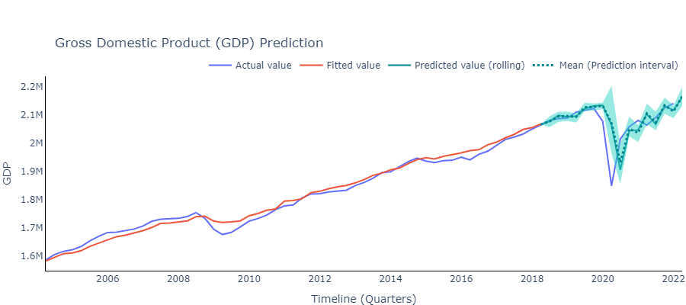

Figure 10: Fitted and predicted GDP value along with prediction band

## **Results Obtained for Retail Trade Sales**

Following the same path, we select model for Retail Trade sales by making comparison of prediction errors of all the considered models, presented in Table 6.

Table 6. Prediction error with different model for indicator Retail Trade Sales

|  |  |  |  |
| --- | --- | --- | --- |
| **Method** | **Predicted RMSE** | **Parameter Tuning** | **Used predictors** |
| DFM + ARIMA | 2,828,358 | Number of factors | 396 predictors |
| LASSO | 2,379,342 | Penalty parameter | 396 predictors |
| Random Forest | 2,281,435 | Number of trees (100) | 396 predictors |
| PCA + XGBoost | 3,410,734 | Number of trees | 396 predictors |

The prediction error of the model Random Forest model is least so this model is selected for making predictions.

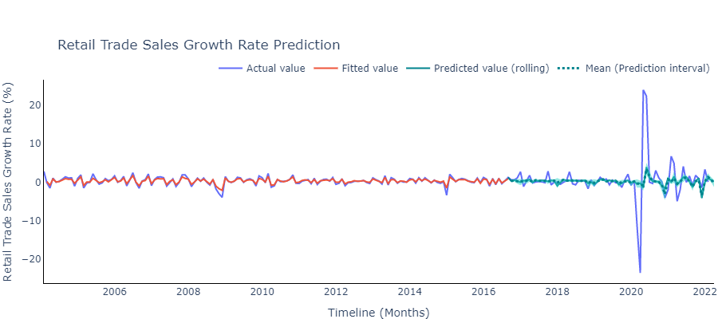

Figure 11: Fitted and predicted Retail Trade Sales growth rate along with prediction band

Figure 12: Fitted and predicted Retail Trade Sales along with prediction interval

The obtained results for Retail Trade Sales growth rate are depicted in Figure 11 and the fitted and predicted value for Retail Trade Sales are presented in Figure 12, the prediction band for Retail Trade Sales is also shown along with its mean. Both the plots exhibit a good model fit and predictions. We can observe the prediction band is not much visible here as the prediction band is really narrow for this indicator, the reason could be the variations in growth rate of Retail Trade Sales are very small which provides us almost similar bootstrap samples and generates prediction band somewhat similar to the predictions made by using training set. The zoomed-in version of the plot can be seen on the dashboard which provides more detailed information on prediction band.

## **Results Obtained for E-Commerce Sales**

Following the same direction, we select model for E-Commerce Sales by making comparison of prediction errors of all the considered models, presented in Table 7.

Table 7. Prediction error with different model for indicator E-Commerce Sales

|  |  |  |  |
| --- | --- | --- | --- |
| **Method** | **Predicted RMSE** | **Parameter Tuning** | **Used predictors** |
| ARIMA | 367,267 | Number of factors | 31 predictors |
| LASSO | 343,505 | Penalty parameter | 31 predictors |
| Random Forest | 298,196 | Number of trees (600) | 31 predictors |
| XGBoost | 338,608 | Number of trees | 31 predictors |

The obtained results for E-Commerce sales growth rate and value are demonstrated in Figures 13 and 14 respectively.

Figure 13: Fitted and predicted E-Commerce Sales growth rate along with prediction band Chart

Description automatically generated

Figure 14: Fitted and predicted E-Commerce Sales along with prediction band

The growth rate prediction follows the trends slightly but not completely as it is really hard to figure out the categories and keywords that may indicate the E-Commerce sales as the E-Commerce sector is relatively smaller than GDP and Retail Trade Sales and less intuitive. We manually extracted 31 keywords which help us to make prediction to some extent but there is room for improvement.

# **Impact of Google Trends**

As we use Google Trends data to make prediction of macroeconomic indicators, so we wanted to investigate if Google Trends really make any improvement in predictions or not. To investigate so, we performed check on GDP and used the same model DFM+ARIMA with exactly same parameters twice, firstly considering both lagged series and Google Trends as predictors and then by using only lagged series as predictor (no Google Trends). The model fit with Google Trends and without Google Trends are depicted in Figures 15 and 16 respectively.

Figure 15: Fitted and predicted GDP by DFM+ARIMA using Google Trends

Figure 16: Fitted and predicted GDP by DFM+ARIMA without using Google Trends

We can see the model fit changes a lot if do not use Google Trends and we will not be comfortable using the model fit, shown in Figure 16, for making predictions. However, the model depicted in Figure 15 is able to fit the decline in GDP really well. Moreover, we have increased train set here in order to include the pandemic period in the model fit which can give us an estimate of how the model fit changes if there is any sudden dip or surge in macroeconomic indicator. The figures explains that the model by using Google Trends is comparatively better than the other one.

# **Challenges**

We extract Google Trends samples for different categories or keywords or queries to use as predictors for our analysis. It has been said in earlier studies that these samples are inconsistent which means there is possibility that data may change if we call Google Trends API on different days, as shown in Figure 17. The Figure 17 shows how the trend for same category ‘Auto & Vehicles’ has changed slightly when we call API on May 11, 2022, and May 12, 2022.

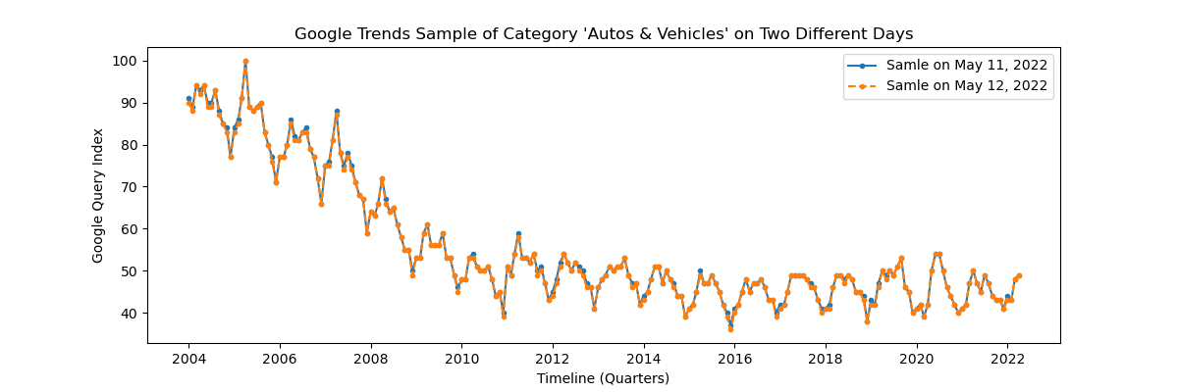

Figure 17: Google Trends for same category on two different days

The ideal way is to extract data of same categories/keywords on different days and take the average of those obtained samples and then use the averaged sample of categories/keywords for further analysis as the averaged sample is consistent. We are extracting monthly data and observe no drastic change in samples on consecutive days, so we have used one sample for our analysis. In addition to that, we have used one sample due to time constraint as we had to wait for 10 days to get 10 samples of the data.

# **Conclusions and Future Directions**

This study shows that the use of Google Trends can help in capturing the trends in macro-economic indicators in a nation. This analysis is specifically devoted to nowcast the GDP, Retail Trade Sales and E-Commerce Sales in Canada that can assist Statistics Canada in decisions making and policy making. For making predictions of considered macroeconomic indicators both the econometric and machine learning models have been explored and the analysis suggest DFM+ARIMA is best suitable for GDP and Random Forest for remaining two indicators. To get more robust results, prediction band is calculated which ensures the reliability of the predicted values and gives the indication of variability in predicted values.

To recapitulate, macroeconomic indicators are analysed by using a specific set of predictors (keywords, categories, subcategories, queries) in order to nowcast the values. The comparative study of different models helped us to select the respective models for each of the indicators. The obtained results are described by using visualizations and tables in detailed manner on an interactive dashboard that provides easy access to the results.

Through this analysis, we explored econometric and machine learning models and the predicted trends provide the information on economic state of the nation. Although, the predictions are well but there is room for improvement and some more steps may prove fruitful that we were not able to explore due to time constraint. Some of the steps that can be followed in future are mentioned below:

1. We have many predictors for GDP, 141 categories, 282 top two queries and 23 keywords and we found only 92 predictors useful to make predictions. Although, we tried different combinations of predictors but adding more predictors did not improve our results, but still there is scope to consider some keywords that we might have missed. Perhaps, considering top 5 related queries and related topics may be helpful as we were not able to collect top 5 queries and topics due to the restrictions on API calls.
2. The bootstrap samples for Retail Trade Sales do not vary much, so the obtained prediction band is narrow. There is scope to apply some other techniques to select the more appropriate block size for bootstrap samples. We explored some block sizes like 5, 7 and 9 but all produced almost similar prediction band.
3. The E-Commerce industry is gaining popularity not only in terms of providing convenience to the customers but also since the world is moving towards becoming digitalized, there would be other keywords or categories coming up with the expansion in the sector. The current utilises the hot list of such keywords, there are time when people just search for these words to have a peek over creating just a wish list without making any actual purchase such cases need to be handled differently while building a model.
4. A dashboard is created to show-case all the obtained results and provide information on the prediction band as well. As more granular data is available for the macro-economic indicators, one new tab can be added to visualize the contribution of different sectors in these indicators and to investigate how this contribution of different sectors has been changed over the time. One more tab can be created which can provide user the ability to train and test the model by using different predictors, which will take 2-3 hours to generate the results as the DFM model takes 10-15 minutes to run and bootstrap for three indicators takes roughly 2.5 hours to generate prediction band. However, if we drop the idea of bootstrap then it can be faster, and user will be able to select the set of predictors and can check how the model fit and predictions change by adding more predictors. Moreover, a dropdown can be provided to select any model among the DFM+ARIMA, LASSO, Random Forest and XGBoost to make predictions.
5. Moreover, monthly GDP can also be predicted as the predictors are available with monthly frequency and interpolation may be used to get the monthly data for quarterly response variable GDP value or growth rate.
6. All the indicators are nowcasted at national level and an attempt can be made to predict the indicators at provincial level or at industry level. However, it might be hard to figure out the keywords for that, but efforts can be made.

# **References**

[1] H. Choi, H. Varian, Predicting the present with Google Trends, *Economic record*, *88 (2012)*, 2-9.

[2] Stock, J.H. and Watson, M.W., 2016. Dynamic factor models, factor-augmented vector autoregressions, and structural vector autoregressions in macroeconomics. In *Handbook of macroeconomics* (Vol. 2, pp. 415-525). Elsevier.

[3] Woloszko, N. (2020). Tracking activity in real time with Google Trends, OECD Economics Department Working Papers, No. 1634, OECD Publishing, Paris.

[4] Dauphin, M.J.F., Dybczak, M.K., Maneely, M., Sanjani, M.T., Suphaphiphat, M.N., Wang, Y. and Zhang, H., 2022. *Nowcasting GDP-A Scalable Approach Using DFM, Machine Learning and Novel Data, Applied to European Economies*. International Monetary Fund.

[5] Richardson, A., van Florenstein Mulder, T. and Vehbi, T., 2021. Nowcasting GDP using machine-learning algorithms: A real-time assessment. *International Journal of Forecasting*, *37*(2), pp.941-948.

# **Annexure A. Important Links**

1. Links to the CSV files containing list of **Categories and keywords** used for nowcasting three macroeconomic indicators are given below:
   * **GDP**: <https://github.com/ubco-mds-2021-labs/capstone-project-googletrends_capstone/blob/main/data/keywords_data/GDP.csv>
   * **Retail Trades Sales**: <https://github.com/ubco-mds-2021-labs/capstone-project-googletrends_capstone/blob/main/data/keywords_data/RETAIL_SALES.csv>
   * **E-Commerce Sales**: <https://github.com/ubco-mds-2021-labs/capstone-project-googletrends_capstone/blob/main/data/keywords_data/EECOMMERCE.csv>
2. Link to access **Google Trends**: <https://trends.google.com/trends/?geo=CA>

Python library ‘Pytrends’ is used to access the Google Trends data.

1. Link to GitHub repository to get the North American Industry Classification System (**NAICS**) code of all the categories:

<https://github.com/pat310/google-trends-api/wiki/Google-Trends-Categories>

1. Link to our GitHub repository to access entire code:

<https://github.com/ubco-mds-2021-labs/capstone-project-googletrends_capstone>

1. Link to important scripts in our GitHub repository:

* **script1_extractGoogleTrendsData.py**

This script extracts all the required Google Trends data for all the three macroeconomic indicators and stores it in ‘/data/storeddata’ folder.

Link: <https://github.com/ubco-mds-2021-labs/capstone-project-googletrends_capstone/blob/main/src/code/script1_extractGoogleTrendsData.py>

* **script2_fitModels.py**

This script fits models, makes predictions, implements bootstrap technique and calculates prediction intervals for all the three indicators by using the predictors’ data stored by running script1_extractGoogleTrendsData.py. After fitting models, it stores the predicted and fitted results in ‘/data/storeddata’ folder.

Link: <https://github.com/ubco-mds-2021-labs/capstone-project-googletrends_capstone/blob/main/src/code/script2_fitModels.py>

* **script3_dashboard.py**

This script uses the data stored by script2_fitModels.py and creates dashboard with the information provided by the predicted and fitted data. To update the dashboard with new predicted data we need to deploy dashboard again on Heroku and this deployment can be automated by choosing option in Heroku account.

**Link:** <https://github.com/ubco-mds-2021-labs/capstone-project-googletrends_capstone/blob/main/src/code/script3_dashboard.py>